Interest Calculation for Customers (Interest on Arrears)

Step 1: Incorporating interest indicator in customer master

Path

SAP Easy Access → Accounting → Financial Accounting → Accounts Receivable → Master Records → Change

Transaction Code FD02

We get Change Customer initial Screen

Customer 10571 (Shah Sales Corporation)

Company Code GROW

Press Enter

We get Change Customer General Data Screen

Click Company Code Data Button
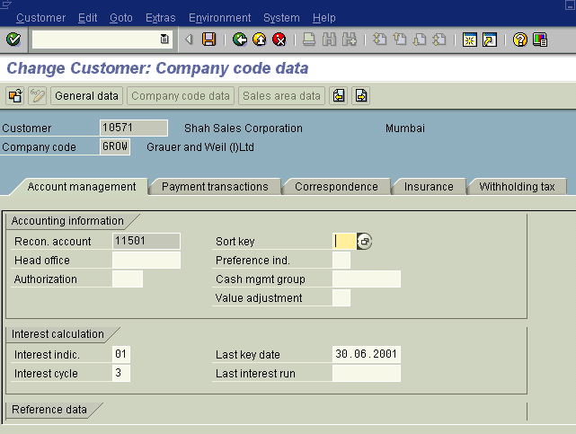

Step2: Interest Calculation

Path

SAP Easy Access → Accounting → Financial Accounting → Accounts Receivable → Periodic Processing → Interest Calculation → Arrears Interest → With open Items

Transaction Code F.2B

We get Calculation of Interest on Arrears Screen as under
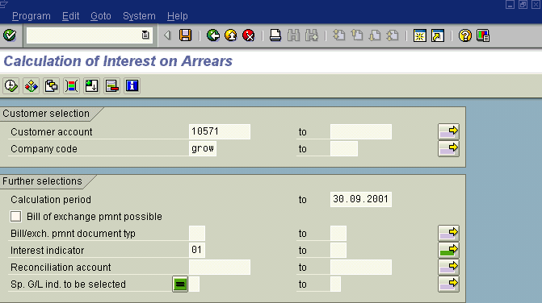
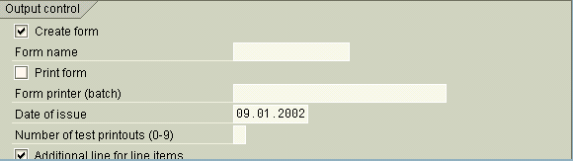
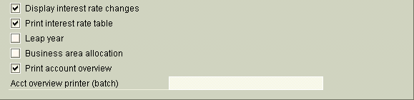
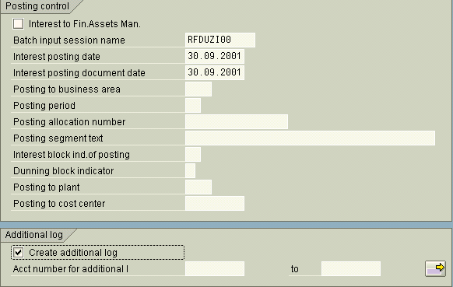

Press Execute F8

We get Display Text Screen where we can see the interest calculated on the following the documents

We get calculation of Interest on arrears screen

Where we get the information batch input session RFDUZI00 created

Then Finally go to

Transaction Code SM35 and run the Batch Input Process

The system will post the interest calculated to books of accounts of the customer.

